UNIT 1.2: Writing a perfect CV

🧠 Brainstorming activity: CVs and cover letters

1. What are some essential do's when creating a CV? (e.g., include relevant work experience, showcase achievements)
2. What are common mistakes or don'ts that should be avoided in a CV? (e.g., using a generic template, including irrelevant personal information)
3. How important is tailoring the CV to the specific job or industry? What benefits does it offer?
4. How important is the visual appearance of a CV? What design elements should be considered?
5. Are there any specific fonts, colours, or layouts that are generally preferred or should be avoided?
6. How can you make sure your CV looks professional when using online job platforms that may have different formatting rules?
7. How can you effectively showcase your skills and achievements in a CV without overwhelming the reader?
8. How important is proofreading and seeking feedback when preparing a CV and cover letter?
9. How do you structure an effective cover letter to make it stand out?
10. What should be the ideal length for a cover letter? How concise should it be?
11. How can you make your cover letter more personalised and engaging to the hiring manager?
12. What's the best approach to address employment gaps in a CV or cover letter?
13. Should employment gaps be explained in the CV or cover letter, or is it better to discuss them during an interview?
14. Share your personal experiences with creating CVs and cover letters. What challenges did you face, and what strategies did you use to overcome them?
15. Have you ever received feedback from employers or recruiters on your CV or cover letter? What did they appreciate, and what areas did they suggest improvement in?
16. Have you noticed any specific changes or trends in CV and cover letter expectations over the years?

🎧 Listening activity: How to write a cover letter

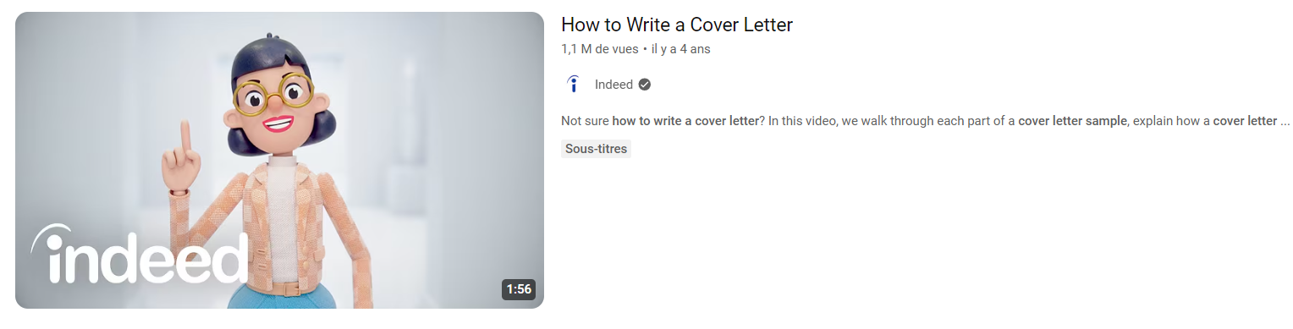

1. **The resume highlights what makes you a great fit for the job.**
   * True
   * False
2. **The cover letter should be readable in ............ seconds or less.**
3. **You should use the title "Hiring Manager" when addressing the person you write to, even if you know their name.**
   * True
   * False
4. **Which paragraph is considered the attention getter? (3 words)**

........................................................................................................

1. **Match each paragraph with the right description.**
   * The opening paragraph _______
   * The middle paragraph _______
   * Thanking the employer _______
2. Followed by a complimentary close and signature.
3. Self-introduction, telling the employer why you're applying for the job.
4. Talk about your skills and qualifications as well as your relevant experience
5. **You should repeat the bullet points in your CV just in case. Sometimes, employers don't have enough time to read your resume.**
   * True
   * False
6. **Together, they ....................! Because what the cover letter does is set up the resume by highlighting what makes you a great fit for the job.**
   * work wonders
   * fit wonders
   * match wonders
7. **So, how do you write a cover letter? Let me ................................... one, literally.**
   * guide you through
   * walk you through
   * run you through
   * talk you through
8. **................................... with a greeting to address the hiring manager.**

a. Kick it off

b. Start it off

c. Jump it off

d. Stick it off

1. **Include why you're excited and how the job ........................ with your career goals.**

a. lines up

b. tags up

c. sticks up

d. starts up

1. **Avoid sounding ............................ by adding keywords from the job posting.**

🧩 Vocabulary: phrasal verbs in CVs/cover letters

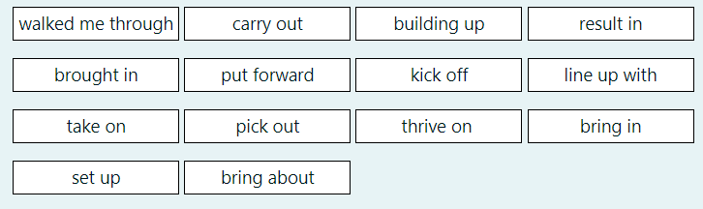

**Complete the following sentences using the words above.**

1. Let's  ……………………….. the meeting by discussing our main objectives. (**= start**)
2. Our marketing strategy needs to  ……………………….. our company's values.
3. Can you help me  ……………………….. a topic for the presentation?
4. My teacher  ……………………….. a demonstration of the software.
5. We need to  ………………………..  this project before the deadline.
6. His innovative approach  ……………………….. substantial revenue for the company last quarter.
7. It's essential to  ……………………….. creative ideas during brainstorming sessions. **(=suggest)**
8. We're planning to  ……………………….. partnerships with several local businesses.
9. Poor planning can  ……………………….. delays in the project.
10. She has a talent for  ……………………….. effective teams.
11. He decided to  ……………………….. leadership of the company when the opportunity arose.
12. The company aims to  ………………………..  skill development through regular training programs.
13. Some people  ………………………..  tackling difficult tasks.
14. We aim to  ……………………….. tangible results and exceed our clients' expectations.

🖊️ Proofreading exercise: cover letters and CVs

**The following cover letter and CV both contain mistakes commonly made by French speakers. Can you identify all of these errors and suggest corrections?**

Dear Hiring Manager,

I am writing to express my interest for the job of Project Manager that you have advertised. I believe my experience and my competences in informatique and project management make me a strong candidate for this position. I am excited about the opportunity to contribute to your company's success.

In my current position at Global Tech, I am responsable of managing a team of developers and overseeing all phases of project development. I have gained valuable experience in ensuring that projects are completed in the good delay and within budget. My role also includes communicating with clients and stakeholders, which helped me improve my professional career and my communication competences.

Furthermore, I possess a solid background in IT support, having worked as a technician for several years. This experience has allowed me to develop strong problem-solving skills and to be highly reactive to the needs of the users. My ability to adapt to different situations and my passion for new technologies make me confident that I can quickly become a valuable asset to your team.

With a Master’s Degree in Computer Science from Université Pierre et Marie Curie, I have also developed a good level in technical knowledge, including Java, Python, and SQL. In addition, I am fluent in both English and French, allowing me to communicate effectively in an international environment.

I am interessed by the opportunity to work at Tech Innovators because of your reputation for leading-edge projects and innovation in the IT field. I would welcome the chance to further discuss how I can contribute to the success of your projects and assist in the development of your team.

Thank you for considering my application. I stay available for any further information you may require or for an interview.

Sincerely, John Martin

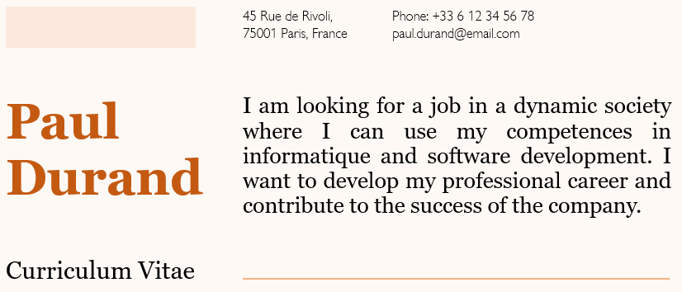

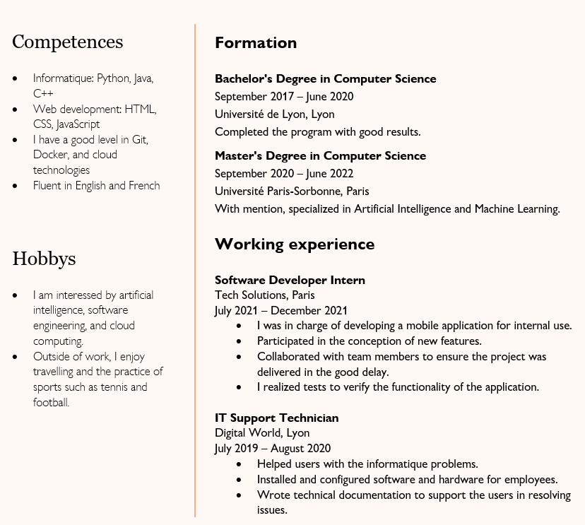

❤️ Theory: Curriculum Vitae and cover letters

Creating a strong CV (Curriculum Vitae) is crucial for making a positive impression on potential employers. Here are the steps to make a good CV:

**1. Choose the Right CV Format:**

* Use a chronological format if you have a consistent work history.
* Use a functional or skills-based format if you want to highlight your skills and qualifications over your work history.
* A combination format combines elements of both chronological and functional formats.

**2. Contact Information:**

* Include your full name, phone number, email address, and, if applicable, your LinkedIn profile or personal website.

**3. Write a Strong Summary or Objective Statement:**

* Create a brief statement at the beginning of your CV that summarizes your career goals and what you bring to the table as a candidate.

**4. Highlight Your Professional Experience:**

* List your work experience in reverse chronological order, starting with your most recent job.
* Include the name of the company, your job title, dates of employment, and a description of your key responsibilities and accomplishments for each position.

**5. Emphasize Achievements:**

* Use bullet points to highlight specific achievements and results in each role, such as increased sales, improved processes, or completed projects.

**6. Showcase Your Education:**

* Include your educational background, starting with your most recent degree.
* Mention the name of the institution, degree earned, graduation date, and any relevant honors or awards.

**7. List Relevant Skills:**

* Include a section that highlights your skills, both technical and soft skills, relevant to the job you're applying for.
* Tailor this section to match the specific job requirements.

**8. Add Additional Sections (Optional):**

* Depending on your background and the job you're seeking, you can include additional sections such as certifications, professional memberships, publications, volunteer work, or languages spoken.

**9. Use Action Words:**

* Use strong action verbs to describe your accomplishments and responsibilities, such as "managed," "implemented," "achieved," or "led."

**10. Keep it Concise:**

* Aim for a CV length of one or two pages, unless you have extensive relevant experience that justifies a longer CV.

**11. Tailor Your CV:**

* Customize your CV for each job application by emphasizing the skills and experiences most relevant to the specific role.

**12. Proofread and Edit:**

* Thoroughly proofread your CV for spelling and grammatical errors.
* Consider having someone else review it for feedback and accuracy.

**13. Choose an Appropriate CV Template:**

* Use a clean and professional template that is easy to read and visually appealing.

**14. Be Honest:**

* Be truthful about your qualifications and experiences. Exaggerating or providing false information can damage your credibility.

**15. Include References:**

* You can either include references on your CV or state that they are available upon request. Make sure you have obtained permission from your references before listing their contact information.

**16. Format Consistency:**

* Maintain a consistent format throughout your CV, including fonts, bullet points, and headings.

**17. Use Keywords:**

* Incorporate relevant keywords from the job description to increase the chances of passing through applicant tracking systems (ATS) used by many employers.

**18. Keep it Updated:**

* Regularly update your CV to reflect your most recent experiences and achievements.

**What is the difference between a CV and a cover letter?**

**CV (Curriculum Vitae)**

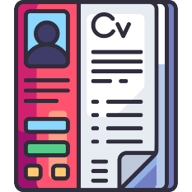**A CV is a comprehensive document that provides a detailed overview of your education, work experience, skills, achievements, and qualifications. Its primary purpose is to present a comprehensive and chronological summary of your professional history.**

➡️ Content: A CV typically includes:

* Personal information (name, contact details).
* Summary or objective statement (optional).
* Education history, including degrees, institutions, dates, and any relevant honors or awards.
* Work experience, listed in reverse chronological order, including job titles, employers, dates, and descriptions of responsibilities and achievements.
* Skills, both technical and soft skills.
* Certifications, licenses, or relevant training.
* Publications, presentations, or other academic or professional achievements.
* Professional memberships or affiliations.
* References or a statement indicating that references are available upon request.

➡️ Length: A CV can be longer than a cover letter and is often two or more pages in length, depending on your level of experience and qualifications.

➡️ Audience: Your CV is typically shared with employers or hiring managers to provide a detailed overview of your qualifications and experiences. It's often used when applying for academic positions, research roles, or jobs in industries where a comprehensive history is essential.

**Cover Letter**

**Purpose: A cover letter is a brief, personalized document that accompanies your CV or resume when you apply for a job. Its primary purpose is to introduce yourself, explain why you are interested in the position, and highlight how your skills and experiences make you a strong candidate for the role.**

➡️ Content: A cover letter typically includes:

* Your contact information (at the top).
* The employer's contact information (if available).
* A greeting to the hiring manager or recipient.
* An opening paragraph that states the specific position you're applying for and how you learned about it.
* Body paragraphs that explain why you're a good fit for the job, citing specific examples of relevant experiences and skills.
* A closing paragraph that expresses your enthusiasm for the position, thanks the reader for their consideration, and includes a call to action, such as requesting an interview.
* Your closing (e.g., "Sincerely" or "Best regards") and your signature.

➡️ Length: A cover letter is typically shorter than a CV, usually one page in length.

➡️ Audience: A cover letter is directly addressed to the hiring manager or employer and is meant to persuade them to review your CV or resume. It provides a personal touch and an opportunity to demonstrate your enthusiasm and communication skills.

|  |  |  |  |  |
| --- | --- | --- | --- | --- |
|  | **CV** | | **Cover Letter** | |
|  | ✔️ | ❌ | ✔️ | ❌ |
| Content | Include comprehensive work history. | Don't include irrelevant details. | Tailor each letter to the job. | Don't repeat your entire CV. |
| Clarity | Use clear and concise language. | Avoid jargon or acronyms. | Clearly state the job you're applying for. | Don't make it overly long. |
| Format | Use a professional and organized format. | Don't use fancy fonts or colours. | Start with a personalized greeting. | Don't use a generic template. |
| Tailoring | Customize it for each job application. | Don't submit a generic CV. | Highlight relevant skills and experiences | Don't mention unrelated skills. |
| Achievements | Highlight specific accomplishments. | Don't provide vague descriptions. | Use examples to support your claims. | Don't make unsubstantiated claims. |
| Keywords | Include relevant industry keywords. | Don't overstuff with keywords. | Address the hiring manager by name (if known). | Don't use a generic salutation. |
| Proofreading | Thoroughly proofread for errors. | Don't rely solely on spellcheck. | Use proper grammar and punctuation. | Don't use slang or informal language. |
| Length | Tailor length based on experience. | Don't make it excessively long. | Keep it concise and to the point. | Don't include unnecessary details. |
| References | Include a "References available upon request" statement. | Don't list references directly on the CV. | Express enthusiasm and interest in the job. | Don't sound disinterested or unenthusiastic. |